Tacolneston and Morley CE VA Primary Schools Federation

SC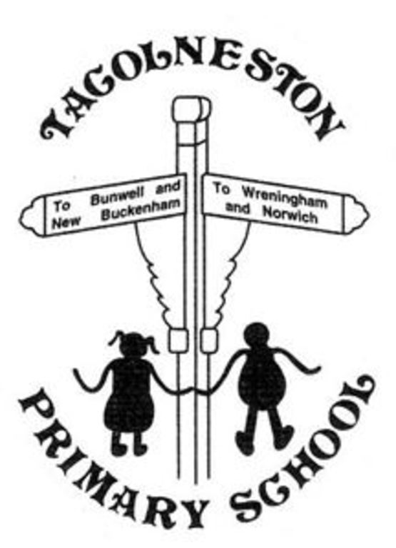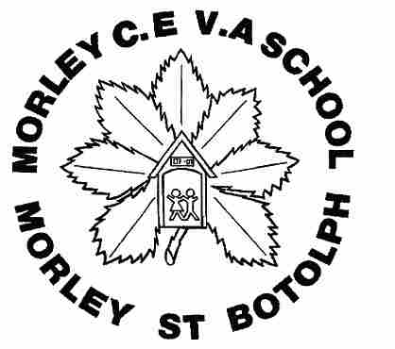IENCE

At our schools we aim for children to develop their knowledge and skills to plan and carry out their own scientific investigation. We encourage our learners to be naturally curious about their environment and ask questions. We also encourage them to observe how science contributes to all aspects of life and to their knowledge and understanding of the world around them. We aim to spark curiosity by having practical experiences with the use of indoor and outdoor environments, including cooking and gardening.

Our aim for children leaving our schools in year 6 is to:
- Have excellent scientific knowledge and understanding, demonstrated with written and verbal explanations.
- Know how to devise a scientific investigation by planning it and carrying it out safely with first-hand experience.
- Have the ability to think independently and use skills of enquiry to ask scientific questions, utilising previous scientific knowledge and understanding.
- Make cross curricular links and understand the importance of other subjects and skills within science (for example tables and graphs in maths, using data loggers in ICT).

Early Years Foundation Stage

In the EYFS children are given free opportunities to explore science in both indoor and outdoor environments. Through the early learning goals children are taught to explore similarities and differences of places, objects, materials and living things. They become confident in talking about and making observations of animals, plants and changes in their environment.

Key Stage 1 & 2

Science books are used throughout the federation for children to record their subject knowledge and investigations. They follow children through the school so they are able to see previously learnt concepts and phenomena.

Children study various topics in biology, physics and chemistry in line with National Curriculum expectations. By planning a two year rolling programme we are able to plan for progression across topic areas. Children are able to revisit and apply previous knowledge and skills to new investigations.

Our creative curriculum allows us to explore some scientific areas through topic work, for example: linking a Roman topic with rocks via volcanos. But some scientific areas are taught in isolation as set out in our rolling programme. The Science Lead looks closely at the Science Curriculum to ensure full coverage of scientific knowledge and to ensure that all children have hands on experience of working scientifically.

Tacolneston and Morley CE VA Primary Schools Federation
Gemma Wooff 2017

