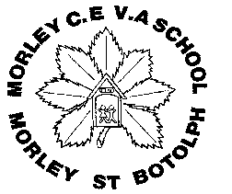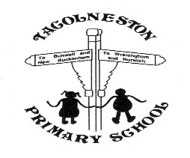

Tacolneston and Morley Federation

**Year 2 PSHE- Relationships Relationships and Sex Education**

**Key Knowledge**

**My feelings**

* Pupils can recognise and celebrate their strengths and achievements and set simple but challenging goals.

**My body**

* Pupils can recognise how they grow and will change as they become older.

**My relationships**

* Pupils can recognise different types of teasing and bullying, and understand that these are wrong and unacceptable.

**My beliefs**

* Pupils can identify the ways in which people and families are unique, understanding there has never been, and will never be, another them.

**My rights and responsibilities**

* Pupils can judge what kind of physical contact is acceptable, comfortable, uncomfortable and how to respond.

**Asking for help-**

Pupils know the difference between secrets and surprises, and the importance of not keeping a secret that makes them feel uncomfortable, worried or afraid

**Vocabulary**

**Differences** – a way in which people or things are not the same

**Similarities** – things that are the same or alike

**Female** – the biological term for a girl or woman

**Vulva-** female genitalia

**Male** - the biological term for a boy or man

**Penis**- male genitalia

**Mammal** – a warm blooded animal, the females of which feed their young milk

**Creation of life** – a new life being formed through a male and a female

**Life-cycle** – the stages a living thing goes through in the stages of its life

**Stages (life-cycle)** -the different parts of a life cycle

**Baby** – a very young child

**Child** -a young human being

**Teenager** -a person aged between 13 and 19

**Adult** -a person who is fully grown or developed

**Elderly person** -a person who is over the age of 65 years

**Human** -a person

**Caring** -displaying kindness and concern for others

**Families** -a group consisting of 2 parents and their children