The Gunpowder Plot – Guy Fawkes
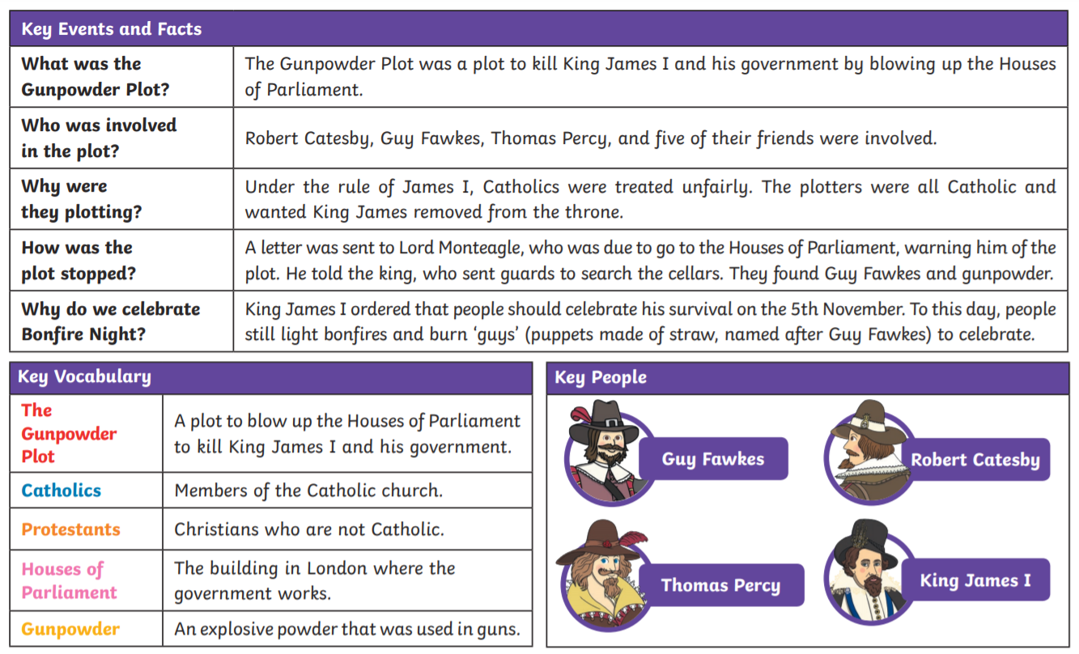
The Gunpowder Plot – Guy Fawkes
