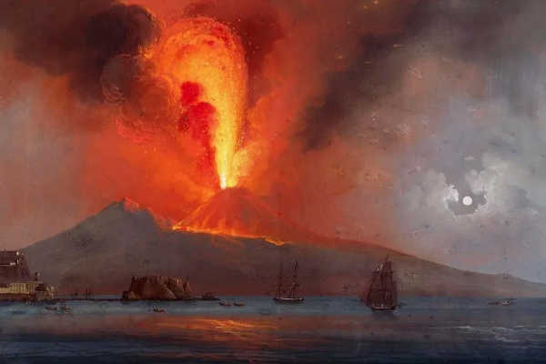
Willow Class – Spring Term
Geography – Explore - The Power of Nature
Value for Life: Justice and Equality
On behalf of last term’s Willow Class team, a big thank you for all your kind Christmas cards and gifts.

Maths
We will be continuing to build on arithmetic skills covered in the autumn term while consolidating formal methods. We will also be looking at fractions and percentages. Children will continue to work with Miss Campbell in Power Maths.
English
As part of our study of volcanoes, we will write a newspaper relating to the eruption of Mount Vesuvius. We will also study poetry and recounts. After half term, we will focus on building up atmosphere and writing narratives linking to our class novel: The Nowhere Emporium by Ross McKenzie.
Science
This term our science topic is forces. We will be investigating how different forces act upon each other. We will also be recording our results to enable us to develop data-handling skills, which link closely to computing and maths.
Humanities
This term our topic theme is geography focussed. We will be looking at the Earth’s structure and what causes earthquakes and volcanoes. We will also locate where the world’s volcanoes are situated in terms of the tectonic plates of the Earth and the lines of longitude and latitude.
French
We will continue to use Rigolo, looking at building vocabulary and confidence.
P.E.
We will be doing outdoor and adventure games on Friday, so please make sure that your child has warm, waterproof clothes and wellies. On a Tuesday, we will be doing dance. After half term we will be doing Tchouk ball and tag rugby.
PSHE
This term we will study keeping safe online and the danger of drugs.
Art/DT
In art, we will look at Pop Art and collage. We will also complete projects with printing and clay after half term.

Music
Performance songs and movement to music linking to dance.

For more detail on the topics we will be covering, please refer to the knowledge organisers on the web page and Google Classroom.

Homework – Homework will be set on a Friday and will be expected to be handed in on a Wednesday. There will be 2 weeks for English tasks. These, along with additional information, will be loaded onto the Google Classroom. Your child can complete tasks online or in their homework book.
Please ensure all homework tasks are completed. Your child will receive weekly activities to complete on My Maths and is expected to read daily. . Your child should write a short summary of what they have read each day in their reading record. Please feel free to write comments in their reading records when you hear them read! Reading with a parent before bed is still incredibly valuable – please do not think your child is too old for this!
These are the revised dates for the KS2 SATs papers due to the coronation of Charles III.
Key Stage 2 SATS
- Tuesday 9 May: English grammar, punctuation and spelling (GPS) papers 1 (questions) and 2 (spelling)
- Wednesday 10 May: English reading paper
- Thursday 11 May: mathematics papers 1 (arithmetic) and 2 (reasoning)
- Friday 12 May: mathematics paper 3 (reasoning)

SATs revision

In the reading paper, children sometimes find reading stamina difficult. They need to read 3 unrelated texts and answer questions for 1 hour (approximately 20 minutes per text) Regularly reading for more than 30 minutes in one go and regularly quizzing on Accelerated Reader will help them develop the stamina they need for this paper.

In previous years, we have offered parents and carers the opportunity to purchase revision books from the CPG website at a reduced rate. Look out for the email from Mrs Ralphs relating to this if you feel that this would benefit your child.

Please do not hesitate to speak to me if you are concerned about anything. I have difficulty accessing the Willow Class direct email, so please email the office if you would like to come in and speak to me or if you would like me to ring you.

