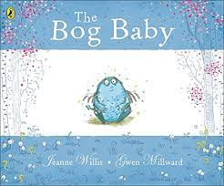
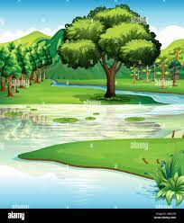
EYFS Knowledge Organiser - Bog Baby
We are learning about …

Seasonal Change
Bodies of Water

bog river pond dell ditch sea lake
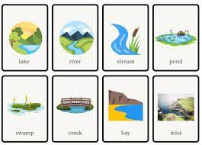

Key Questions
Can you name a sign of spring?
In autumn the leaves …..?
When is it coldest?
Where might a frog or newt live?
What type of water flows into the sea?
What type of water is enclosed?
What type of animal are you?
What types of animals live in water?
Name a bird or an amphibian.

