Summer Term in Pine Class

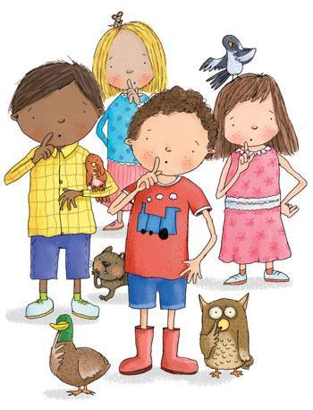

‘LEARN TOGETHER, WORK TOGETHER, GROW TOGETHER’

Dear Parents and Carers,

A huge welcome back to everyone for the start of the summer term, we hope you had a lovely Easter break and are now ready to go!

It is hard to believe that we are already in the final term of your child’s first year in school! We are going to be very busy, but the sun will hopefully shine down on us as we continue to learn together, work together and grow together.

Our learning for the term will focus on:
Wonderful World (Land and Water)

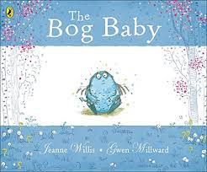

Our first key text is Bog baby. This will lead us into exploring the creatures that we can find on land and in the water, as well as discovering our very own imaginary Bog Baby! We will also be creating our own Bog Babies in a variety of ways as part of art and DT.
Our second key text will be One Day on our Blue Planet in the Savannah which will give us the opportunity to compare and contrast the UK seaside with the savannah. We will also be looking at how the world is being affected by climate change and finding out about the work of the fabulous and legendary David Attenborough and Hamza Yassin from CBeebies.
We will be visiting Africa Alive so that we can consolidate and re-cap from our previous learning on Handa’s Surprise (Dates to follow).

We also have many exciting activities planned to celebrate the King’s coronation on the 6th May.

Reading –We find that it helps to get into a routine with reading by doing it at the same time each day. Children enjoy routine, so this soon becomes part of a regular pattern. We will continue to hear the children at every available opportunity in school, but this should not be their only source of reading:

READING MORNING We look forward to welcoming you in each Friday morning from 8.30-8.45 to spend time with your child reading and sharing books together. The children really look forward to this time, so if you can pop in then we will be glad to see you.

BEDTIME STORYTIME – Friday 30th June 6pm- 5.30-6.15pm
We are keen to have a Bedtime story session this term as reading to children is really such a pleasure (and it is one of the points to tick off for the Going for Gold too).
So, please bring your child to Pine class for 5.30 and then collect again at 6.15pm.
(They can come dressed for bed, and bring their soft cuddly and a pillow with them so that they can get all cosy)!

PE – Please ensure that they come to school in their kits on a Wednesday and that they are wearing the correct kit, we have noticed that children are wearing branded items and the wrong colour. The PE kits must be the following as per our uniform policy:

T-shirt in the colour of their house team
Jogging bottoms and sweatshirt/hoody in either black or navy

Outdoor Education- This will be on a weekly basis. Even though the weather should be more pleasant, please ensure that your child still has a pair of wellies and waterproofs. We will be looking at seasonal change, flowering plants and doing some creative activities too!

LIBRARY BOOKS – children change these on a Friday. Sadly, we are not having some returned, so please make sure Friday is in your diary for library book return.

Morning Drop offs – Please continue to encourage your child to carry and bring in all of their things in one go in the morning. At this stage in the year we need to foster as much independence as possible.

Class Assembly - We will be busy preparing for this important milestone during this term and look forward to seeing you all to celebrate with us on Thursday 4th May. Head to the hall after drop off and we hope to begin at 9am.

Value for Life – As a Church of England school, we follow the values for life, and this term it is Love and Compassion. Please do take every opportunity to chat to your child about this as we will be reflecting on what this means to us as part of Collective Worship and as part of daily school life.

Lastly, as the weather brings more sunshine, children need to come to school with a sunhat, and sun cream (high factor) already applied. Children don’t seek the shade and our lunch play is at the time when the sun is strongest, so please do help your child to have an enjoyable time.

As always, children in our care are always our priority and we know that those parents who become partners in learning truly improve the outcomes for their children.
Please do not hesitate to contact us if you have any questions or concerns.

Kind regards,

Kate Easter and Tabitha Botting

